Curriculum vitae
Dr. Hans SCHRANGL
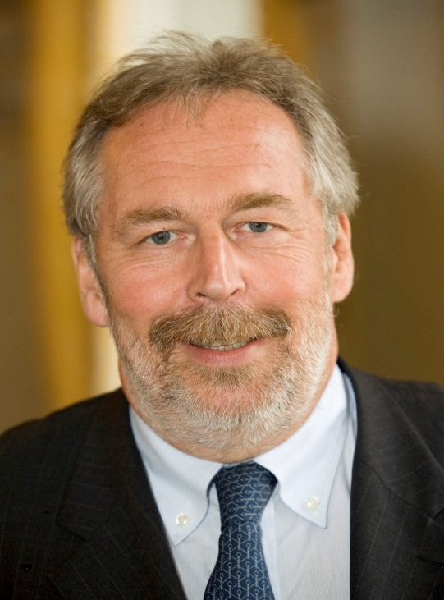
Born 1953 in Linz/Austria
Medical Doctor University of Innsbruck 1978
Degree Dental Medizin (excellent succes) University of Vienna 1980
Military service, Officer in reserve
Assistant Prof. Dental School Vienna – Department Prof. Dr. Rudolf Slavicek 1981/82
Private office in Linz since 1982
Dental Chamber of Upper-Austria: President
Austrian Dental Chamber: Vicepresident
Title „Obermedizinalrat“ given by The President of the Republic of Austria 2014
Austrian delegate to the Dental World Parliament
Austrian delegate to ERO and CED
Member of ERO-WG Dental Team
General Secretary ERO 2013 – 2016
Member CED-Board 2015 - 2018

